Design Cartoon Suite User Guide

Author: Milo Dodds
Last Review Date: June 28, 2014

Table of Contents

Chapter 1 Background and Requirements
What is this? 4
System Requirements 4
Purchasing 4
Installing 4
Application Navigation 5
Workflow: Open, Save, Save As and Export 5
Exporting from Character Creator 6
Exporting from Background Creator 7
Exporting from Storyboard Creator 7

Chapter 2: Character Creator Basics
Character Selection: Gender, Pose and Ethnicity 8
Editing Window 9
4-Up View
Zoom
Grid
Rotate Perspective
Circular Tools Panel 13
Pose: Body Position and Poses 13
Expression
Attire
Library
Transform sliders
Mouse transformations
Paint
Random

Chapter 3: Background Creator Basics
Background Selection: 16
Editing Window
Zoom
Grid
Full Screen
Circular Tools Panel
Background
Library
Layers
Characters
Transform
Paint
Import

Chapter 4: Storyboard Creator Basics
Layout Selection
Background Image
Library
Layers
Text
Transform
Paint
Import

Chapter 5: Character Creator Advanced
How-to modify characters to look younger or older
How-to modify facial expressions
How-to create monsters and aliens

Chapter 6: Background Creator Advanced
How-to create your own backgrounds
How to mirror and rotate images
Perspective (sizing characters and objectives)

Chapter 7: Storyboard Creator Advanced
How-to create a comic book

Chapter 8: Printing
PDF Export
JPEG/PNG Export

Chapter 9: Technical Support & Updates
FAQS
Blog
Email Support
Adobe AIR Updates
Product Updates
Uninstalling

Appendix A: End User License Agreement

Appendix B: Business Justification Matrix

Appendix C: Features and Workflow Job Aid

Chapter 1: Background and Requirements

What is this?
The Design Cartoon Suite is a simple and rapid 2D graphical storyboarding tool. You will be able to illustrate compelling human interactions in a graphical novel approach.

Though it helps immensely to have the talent to tell a great story, you won’t have to actually draw anything by hand unless you want to import your own drawings, nor will you have to go out and hire a professional illustrator during the storyboarding stage.

It’s taken several years to design and develop the Design Cartoon Suite. Our hope is that you will love this software and use it all the time. Release 1.0 is a starting point to hopefully a much longer product development life cycle and we invite you to join us on this exciting journey as an “Early Adopter” and show your support by purchasing either a personal or business/commercial license.

Please feel free to email us your comments, concerns and enhancement requests. We can’t promise that we will be able to make all of your requests possible but we will evaluate every request, prioritize them and get back to you with a reply. Our current list has several dozen features and functions for future our releases. Watch for announcements on the Design Cartoon Blog.

Requirements
The Design Cartoon Suite runs on the MAC OS (Mountain Lion, Lion and Mavericks) as well as Windows 2000, XP and 7. It does not currently run on Windows 8, any prior MAC OS version such as Snow Leopard nor does it run on any tablets.

Please take a look at the system requirements for Adobe AIR , this is the software platform that is required to run the Design Cartoon Suite.

As of this writing the specifications are:

Windows
- 2.33GHz or faster x86-compatible processor, or Intel Atom™ 1.6GHz or faster processor for netbook class devices
- Microsoft® Windows® XP, Windows Server 2008, Windows Vista® Home Premium, Business, Ultimate, or Enterprise (including 64 bit editions) with Service Pack 2, Windows 7, or Windows 8 Classic
- 512MB of RAM (1GB recommended)

Mac OS
- Intel® Core™ Duo 1.83GHz or faster processor
- Mac OS X v10.6, v10.7, v10.8, or v10.9
512MB of RAM (1GB recommended)

Purchasing
You must register via the Design Cartoon Registration Form and create a customer account with a valid email address and supply other important details before you can purchase a copy of the Design Cartoon Suite.

Once registered you will have three options from the Pricing Page: 1) Download a 30-Day Trial Version, 2) Purchase a Personal Use License (Non-Commercial) or 2) Purchase a Business License. Just registering will not make a request for trial version of the software. You must go back to the Pricing Page and click on the appropriate option.

We are trusting your honesty and integrity as to whether you will using the software strictly for personal (hobby use) or whether you will also be using in your day-to-day work-related projects which is considered business/commercial use.

Installing
After requesting a Design Cartoon Suite license you will receive an email that includes two urls. One is for the MAC and the other for the Windows installer in .zip format plus the appropriate 25-digit serial key based on the license you ordered. Download the proper installer for your operating system.

If you install the 30-day trial version you will have an opportunity every time you launch to insert a serial key for a personal or business license. After 30 days you won’t be able launch the program but you will see a screen to insert a non-trial version license.

As mentioned in the requirements we currently do not support the Windows 8 platform nor do we support any tablet device at this time.

Application Navigation
When you first start the Design Cartoon Suite you will see this splash screen:

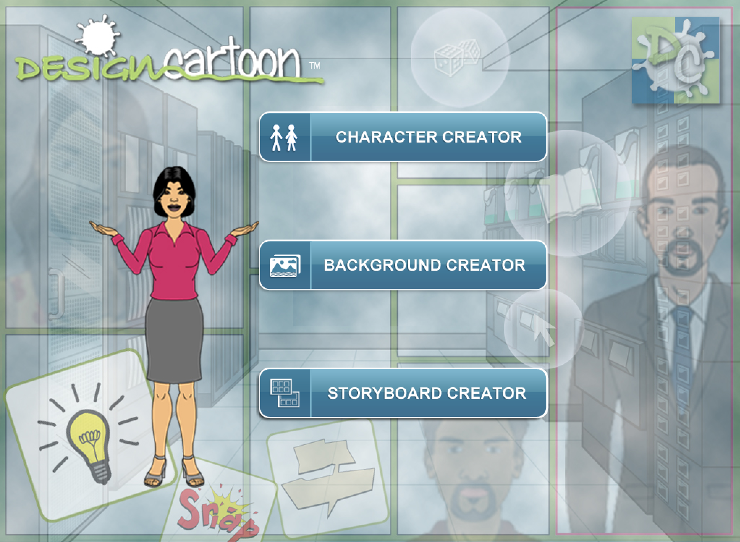

Once you have clicked on one of the three application buttons you can navigate between the three applications using the upper left pull-down.

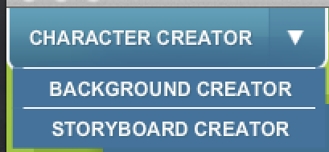

Workflow: Open, Save, Save As and Export
The Open feature opens saved projects files from the DesignCartoon folder. All three tool’s project files are XML-based and do not include any actual images inside of them. The Open, Save and Save As are associated with these XML based project files for all three of the applications.

The Project File Extensions are:

Character Creator | .cc
Background Creator | .bg
Storyboard Creator | .sb

Exporting from Character Creator
When exporting you can create either a JPG or PNG image for both the Character Creator and Background Creator tools, and create the additional PDF format from the Storyboard Creator.

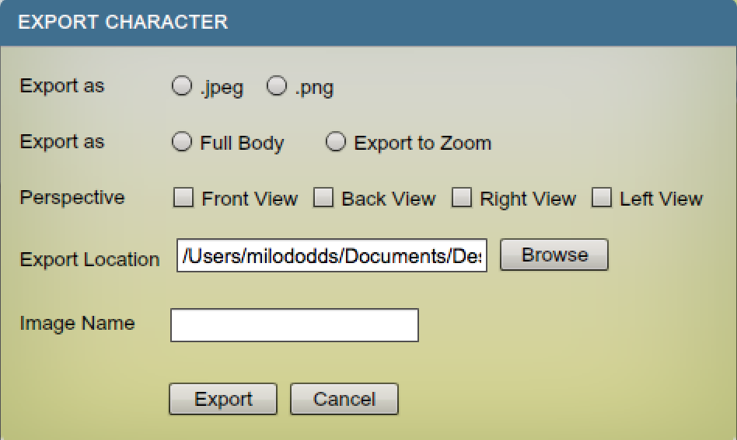

Besides an image difference the .jpeg export will include the background color from the Perspective window while the .png export will make the background transparent.

The Full Body will bring the zoom-level back to 100% and will export the entire character into an image.

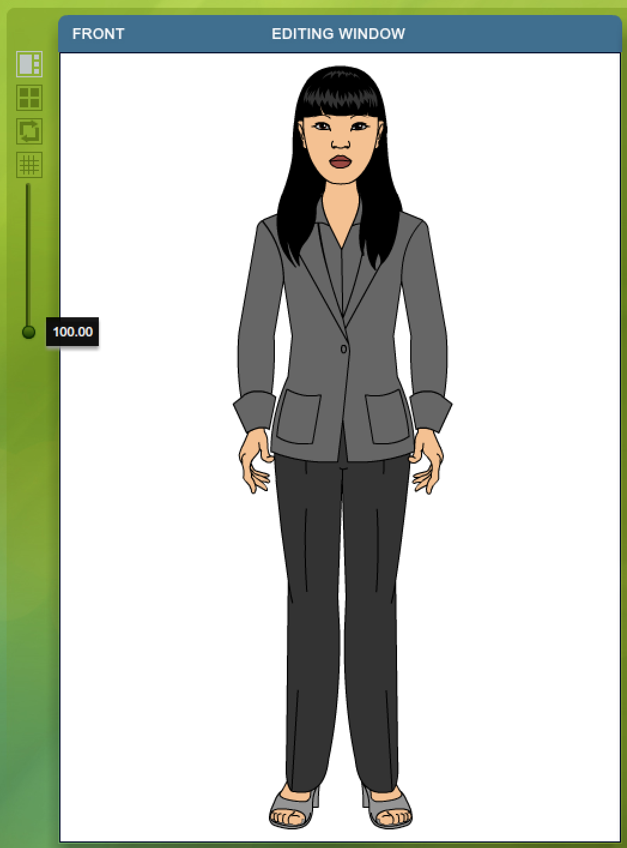

The Export to Zoom will produce the current Zoom of the Editing Window.

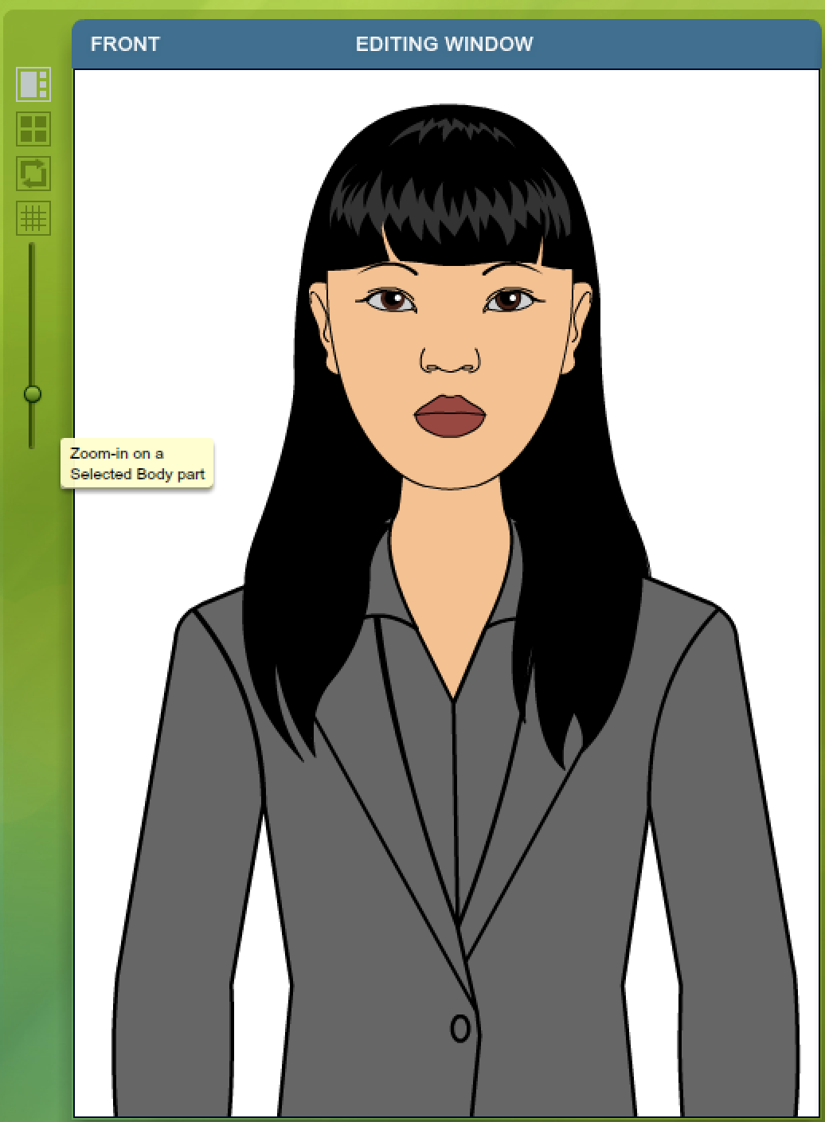

Exporting from Background Creator
You have two possible export resolutions 1) Normal and 2) Full Screen.

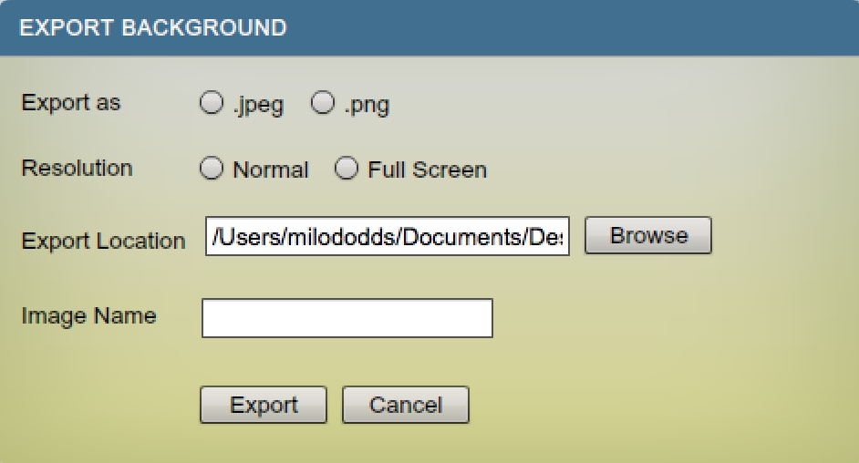

Type in an image name but you won’t need to include the file extension in the name.

Exporting from Storyboard Creator
For your completed content you can also export in PDF format and the resolution for this for Normal is x-y pixels and for Full Screen x-y pixels.

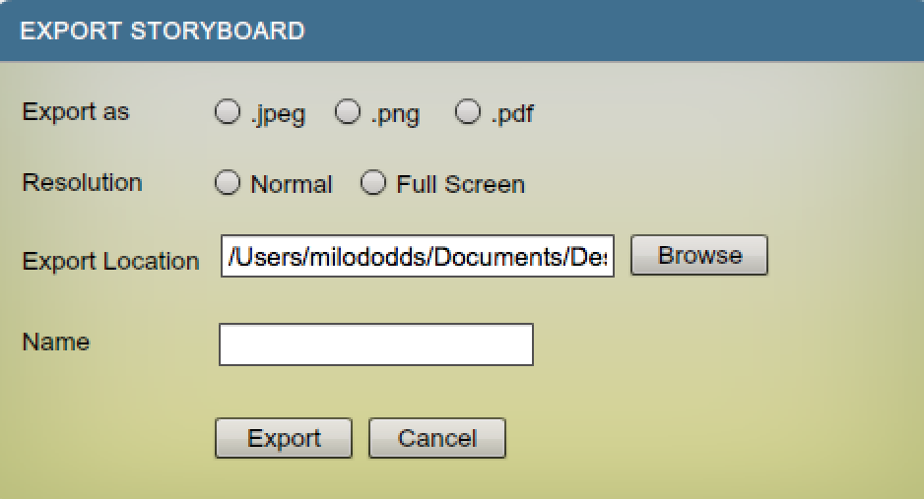

Chapter 2: Character Creator Basics

Character Selection: Gender, Pose and Ethnicity
Beyond offering either male or female gender based characters, we also offer six different ethnicities including: African, Asian, Indian, Middle Eastern, Caucasian and Latin in both sitting and standing positions. These are base characters (a starting point) and we will show you how to modify them to represent almost any possible ethnicity and physical appearance, especially from a facial perspective.

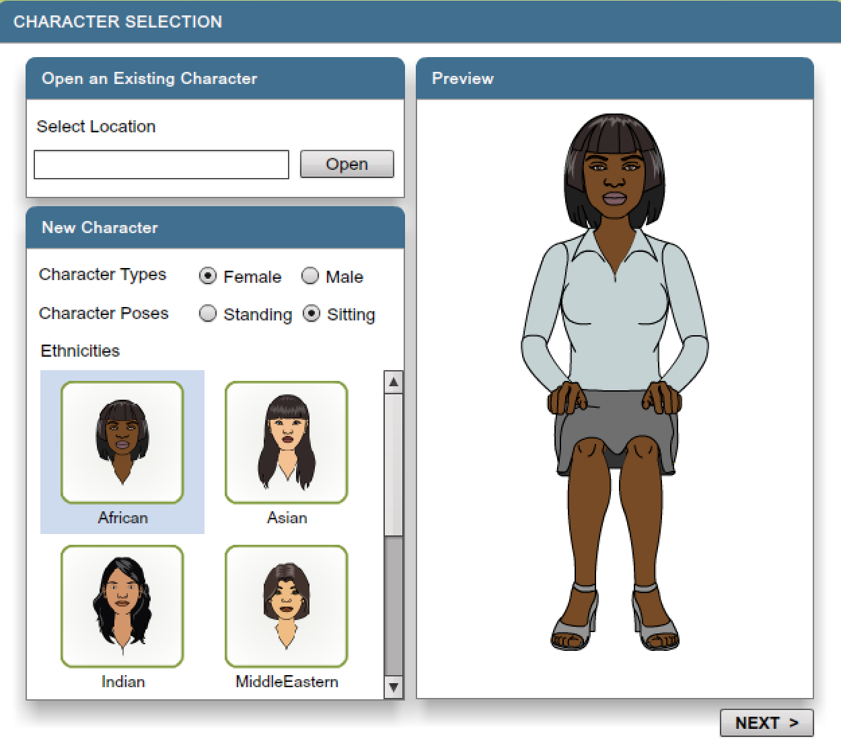

[placeholder for an image with all the characters in it]

Editing Window
The Editing Window (the larger window on the left) is the only one of the four windows where you can edit the character. The other three windows are smaller and are there for viewing how changes in the Editing Window effects the other three perspectives.

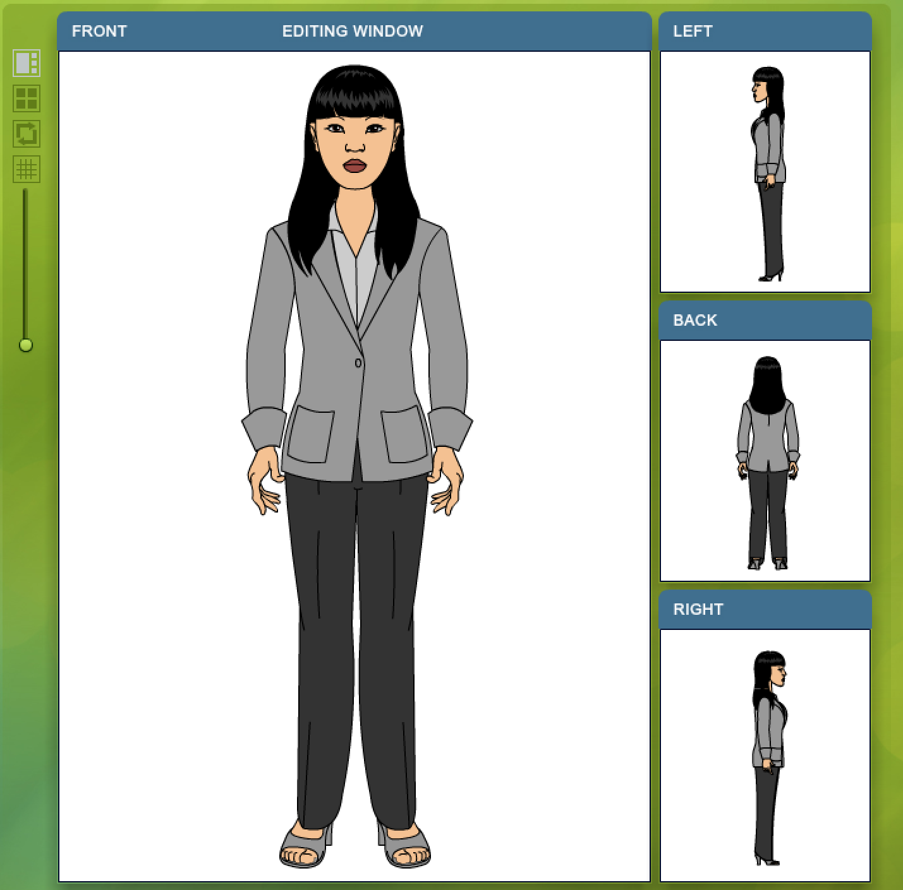

Staying in Synch
All of the body parts are in synch with each other and can be edited up to a certain point. Extensive amounts of editing (skewing/rotating/scaling/moving) can sometimes cause the body parts across other perspectives to go out-of-synch with each other. We recommend that you save different versions of your project file in case you happen to go out-of-synch.

Since the characters are not 3D based because we are working on a 2D plane in each perspective, there is no actual depth (z-axis) that can be controlled. To properly modify body parts requires modify at least two perspectives to provide the 3D appearance. For example I could enlarge a characters hand in the front perspective but it will still appear to be thinner (narrower) in either of the two side perspectives. I would need to go to the appropriate side perspective and widen the hand in order to keep the hand’s width sized properly in all perspectives. This only applies to the x-axis (width) of any object, since all vertical changes (y-axis) are applied across all four perspectives.

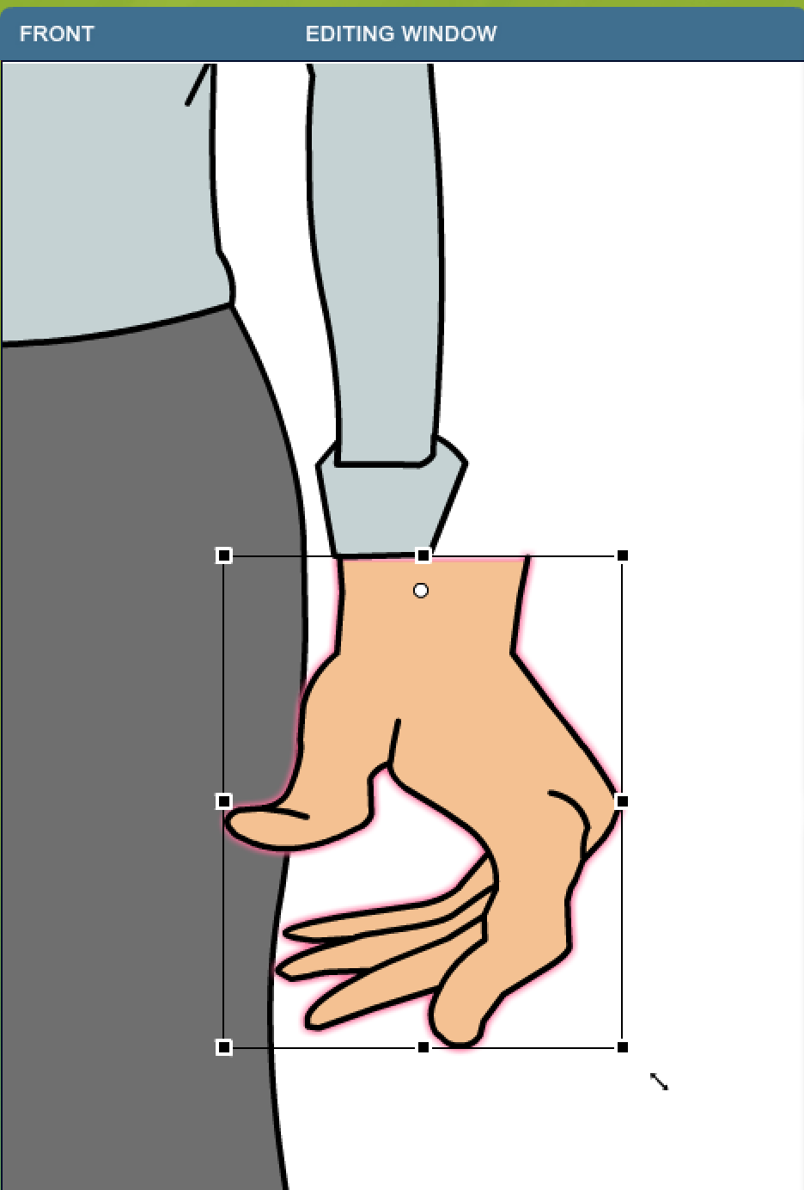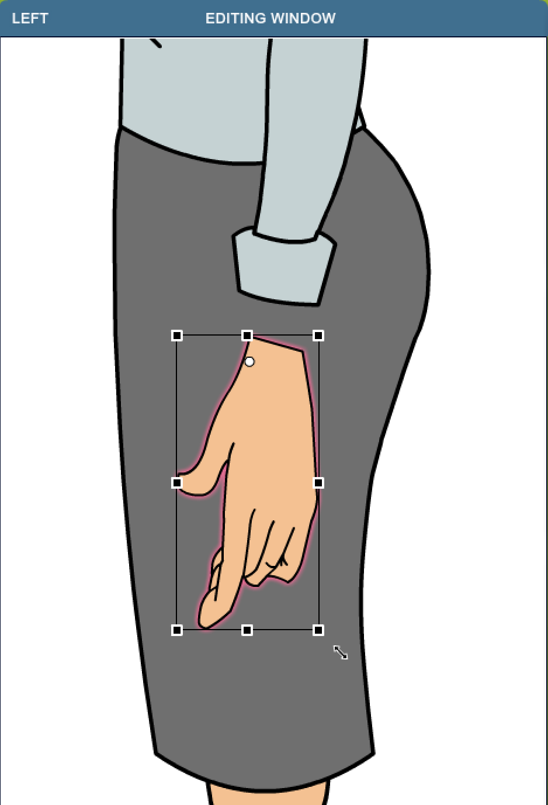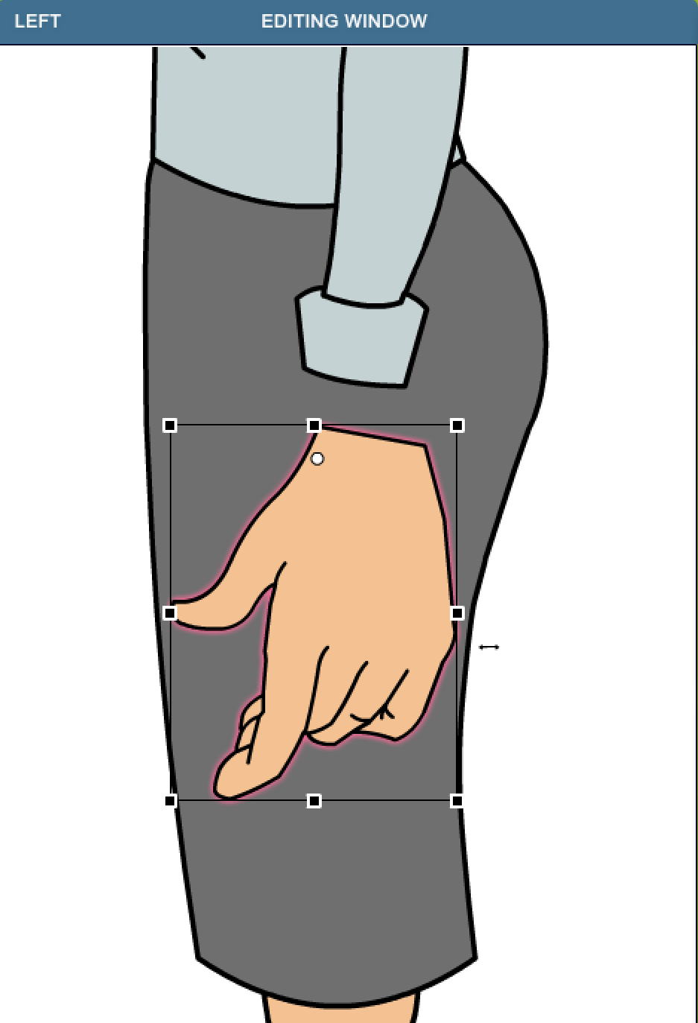

We will show you how to rotate through all four currently supported perspectives (Front, Left, Back and Right).

Four-Up View
The Four-Up View is just for visual viewing and doesn’t offer any editing capabilities. It is a way to see all four perspectives all together.

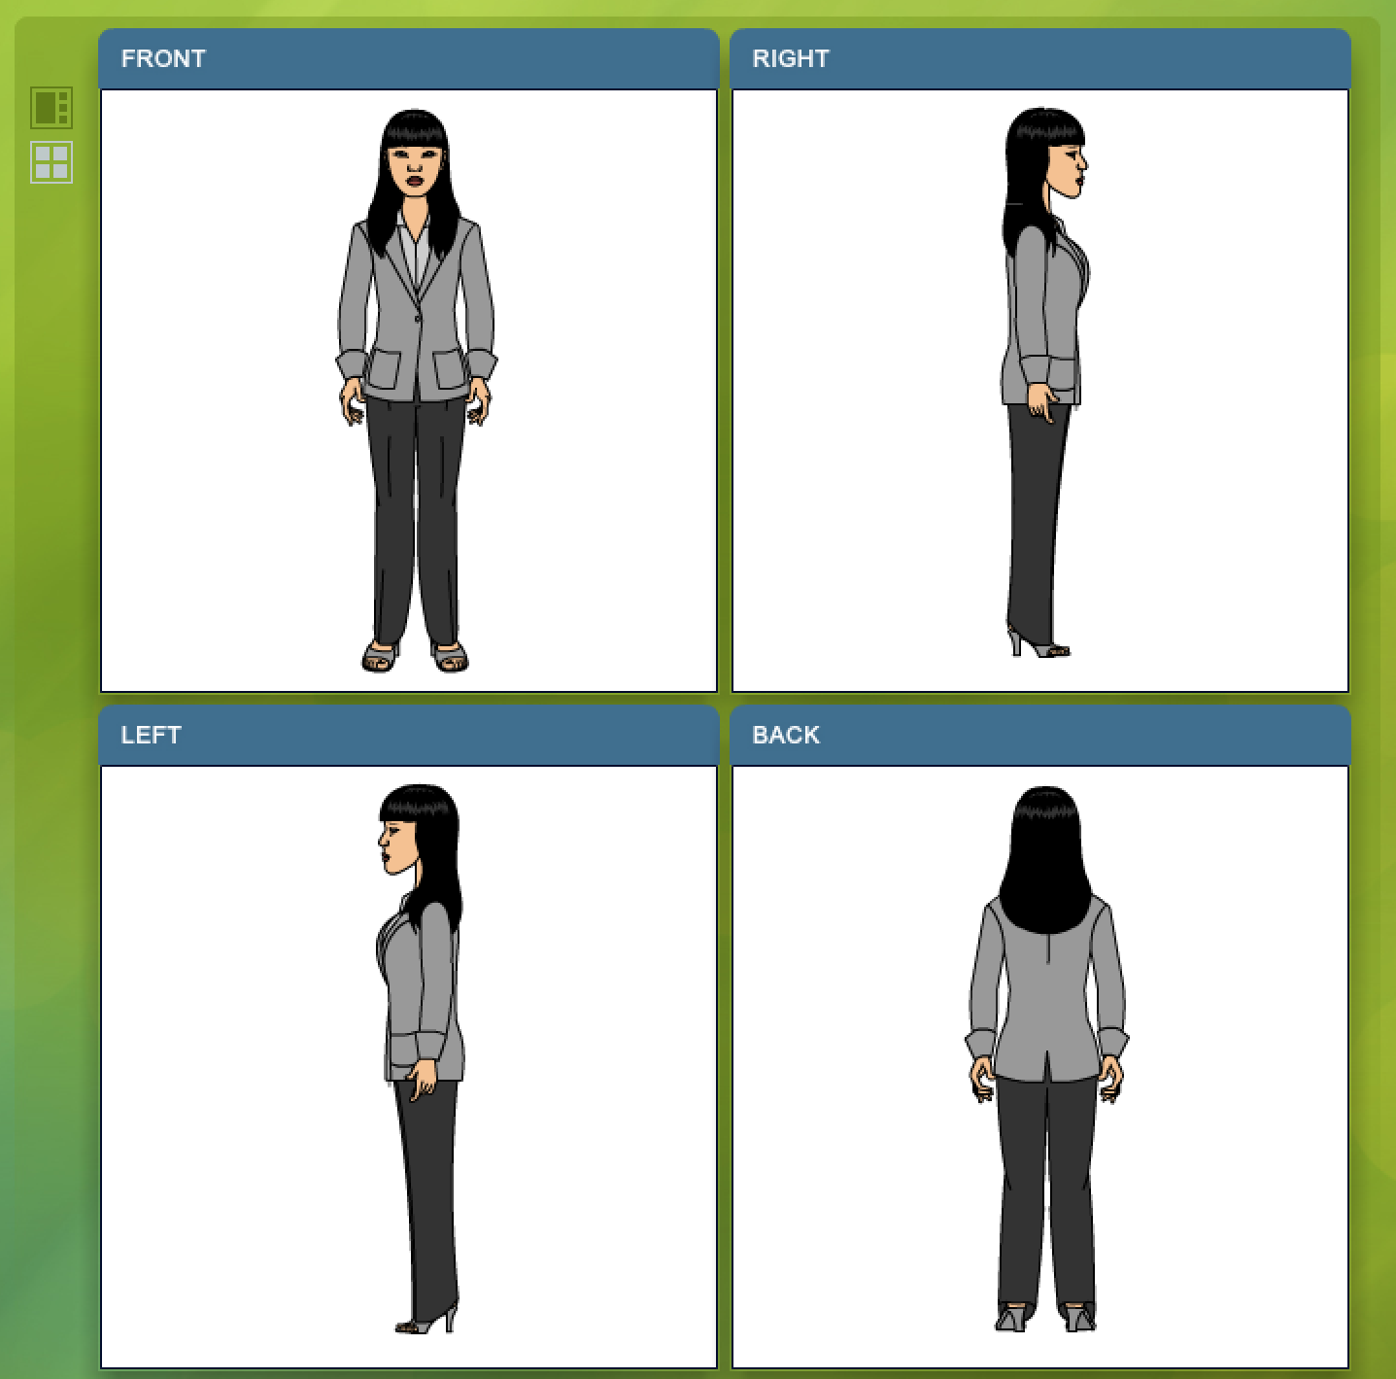

Zoom Slider
This slider bar works in conjunction with highlighting an object in the editing window and making it the center point for the Zoom function.

Her nose has been left clicked and highlighted which will produce a glow red outline of the object and then the Zoom Slider was zoomed onto her nose for a semi close-up. Any body part of article of clothing can be highlighted and used as a center point for the Zoom function.

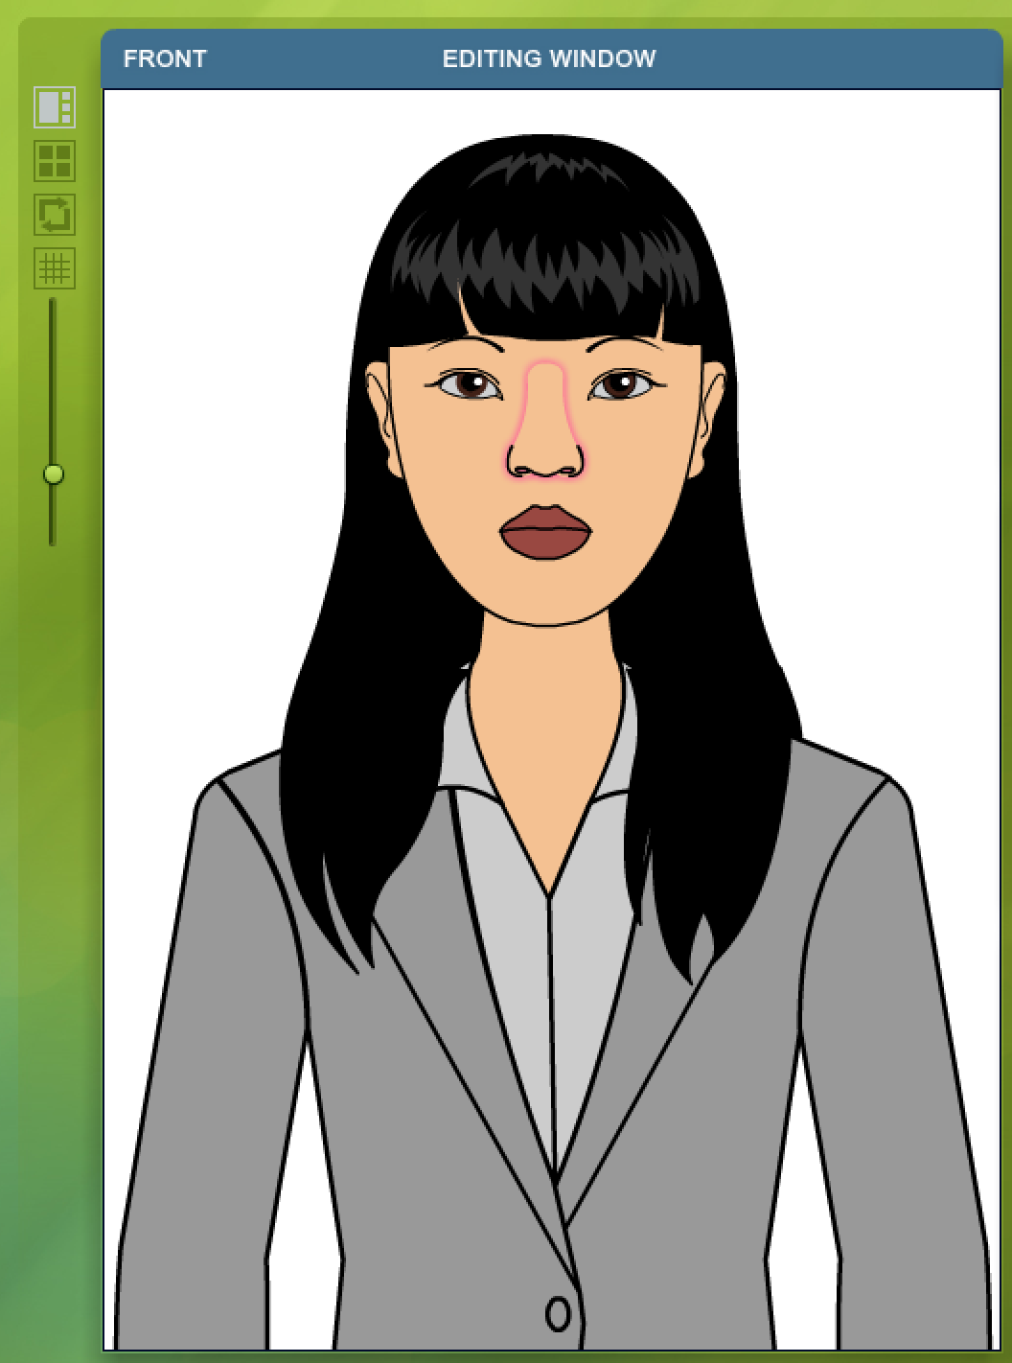

Grid
The Grid Function is important when you are trying to align various body parts or articles of clothing relative of one another. Later on we will cover the Transform Function that works nicely in conjunction with the Grid for finite control.

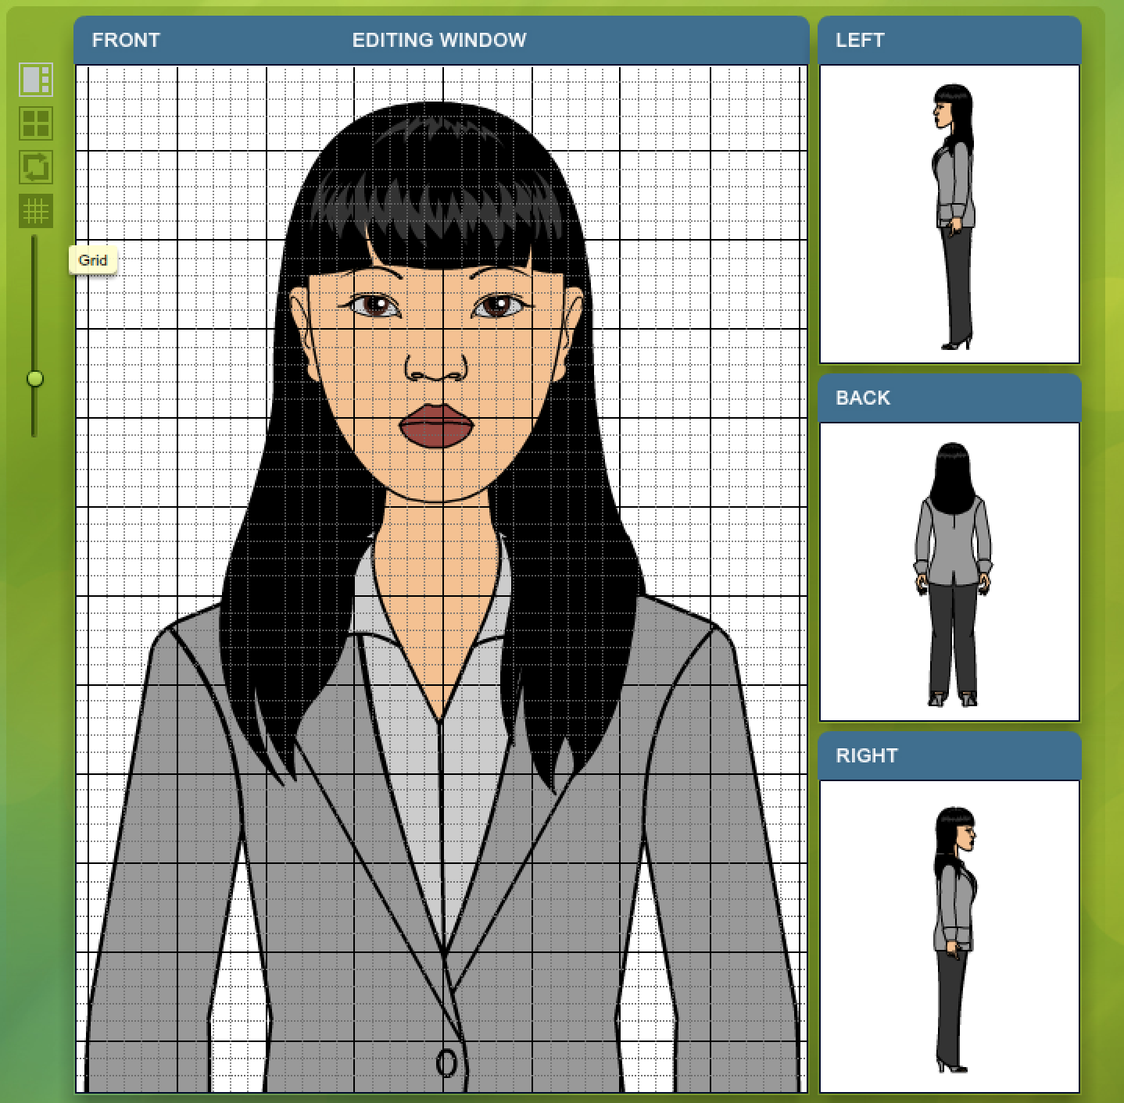

Rotate Perspective
The Rotate icon allows you toggle between each of the four perspectives:

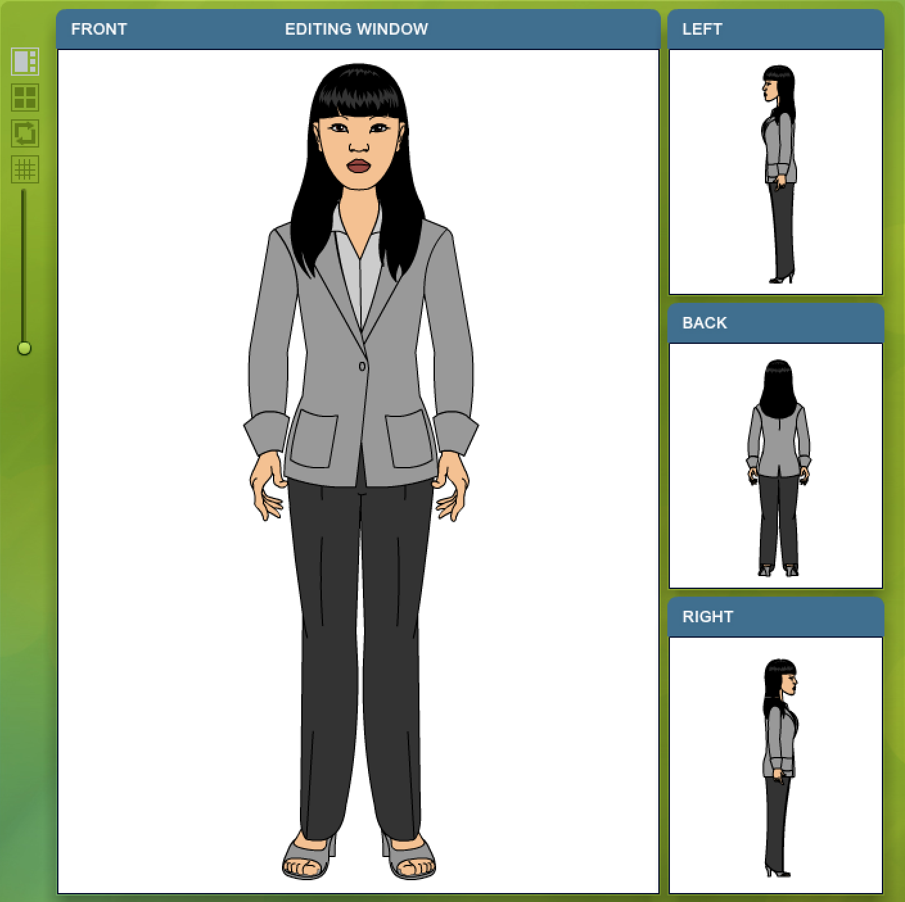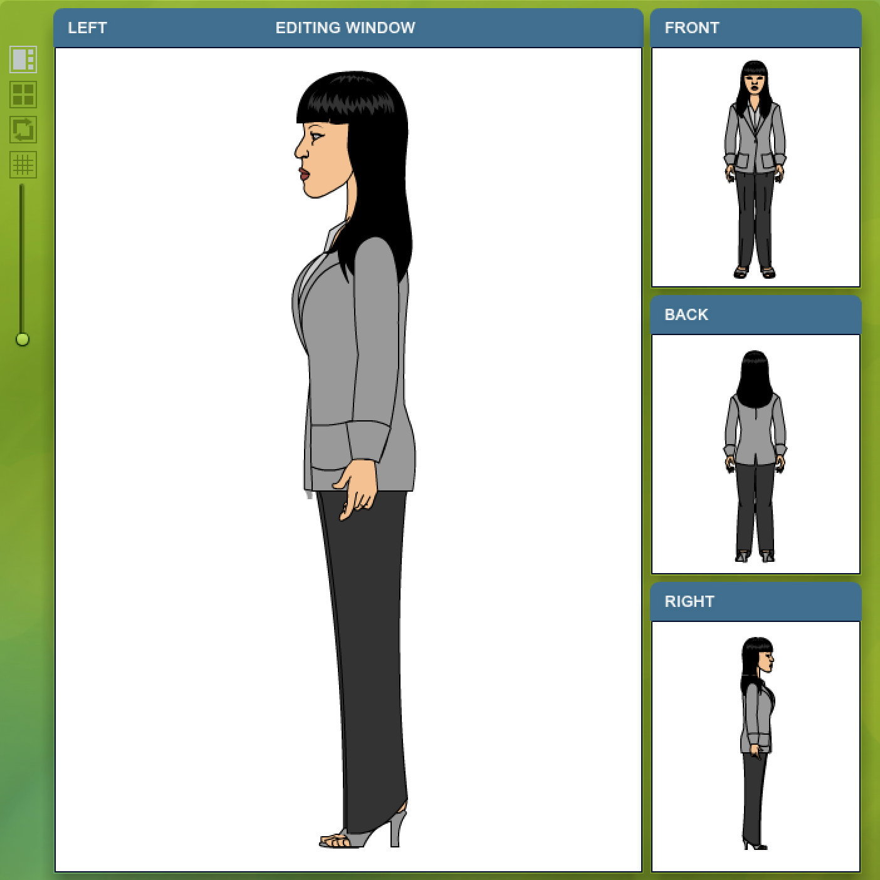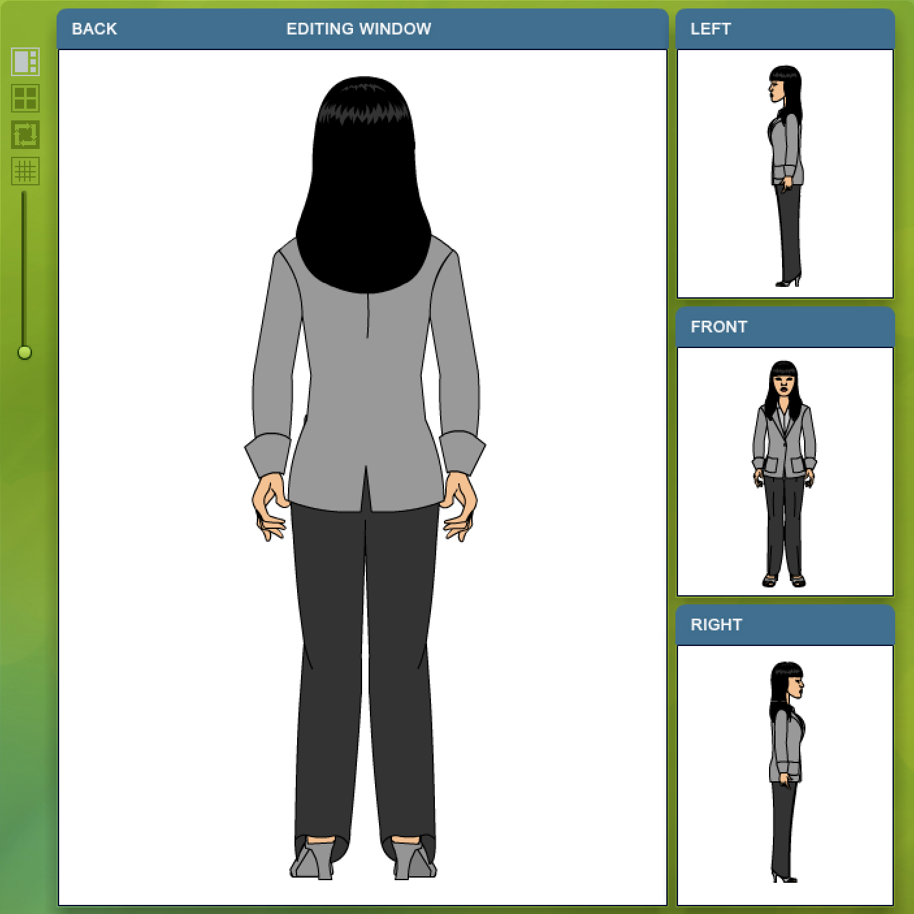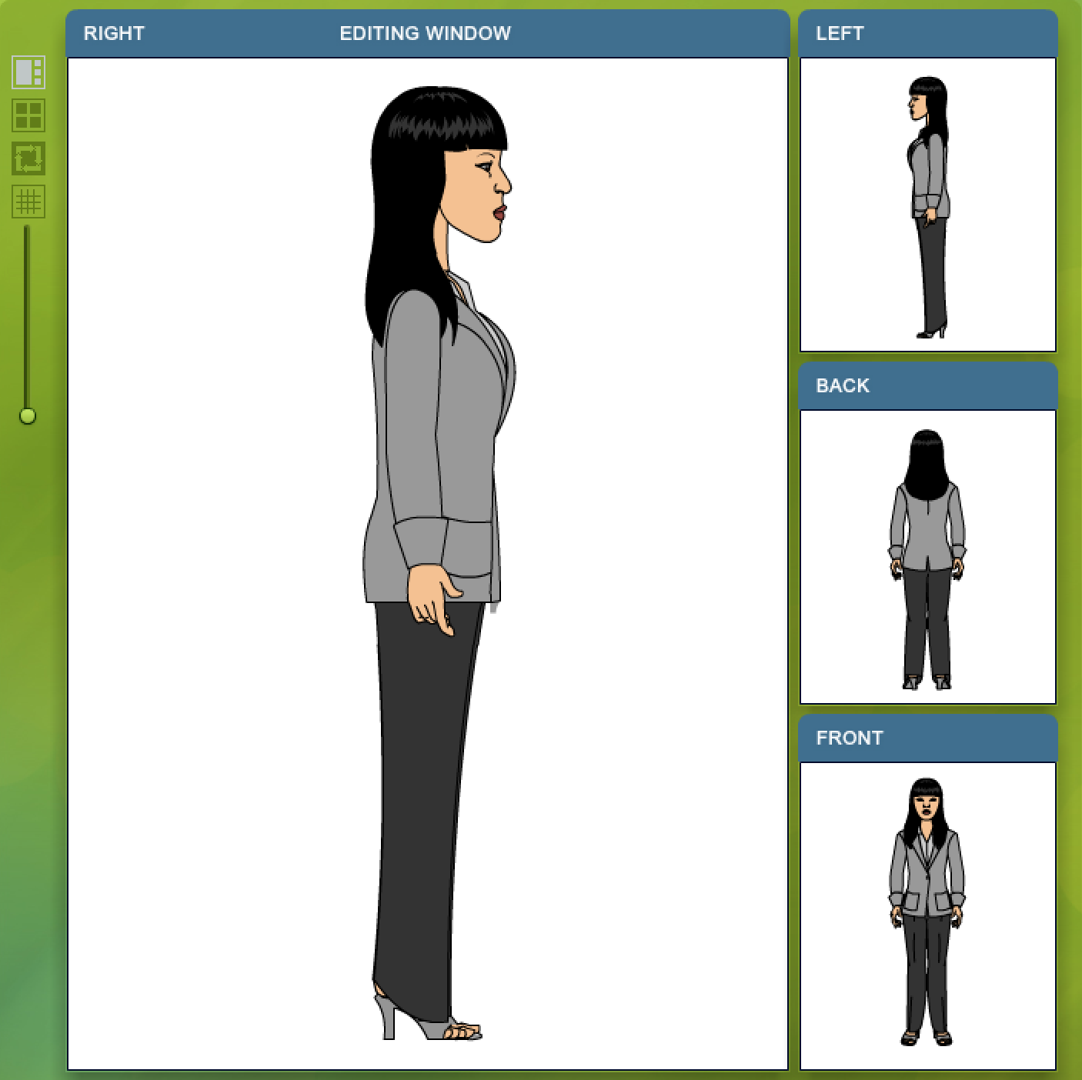

Circular Tools Panel
A majority of the editing features and functions are found to the right of the screen in the circular tools panel:
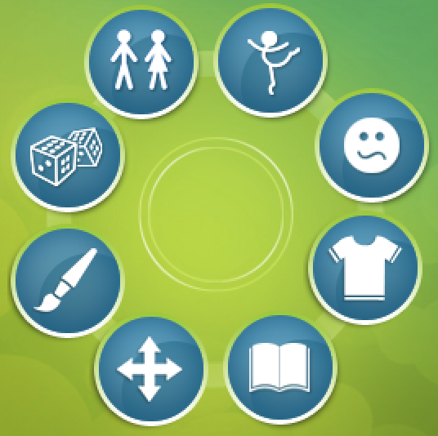

Pose: Body Position and Poses

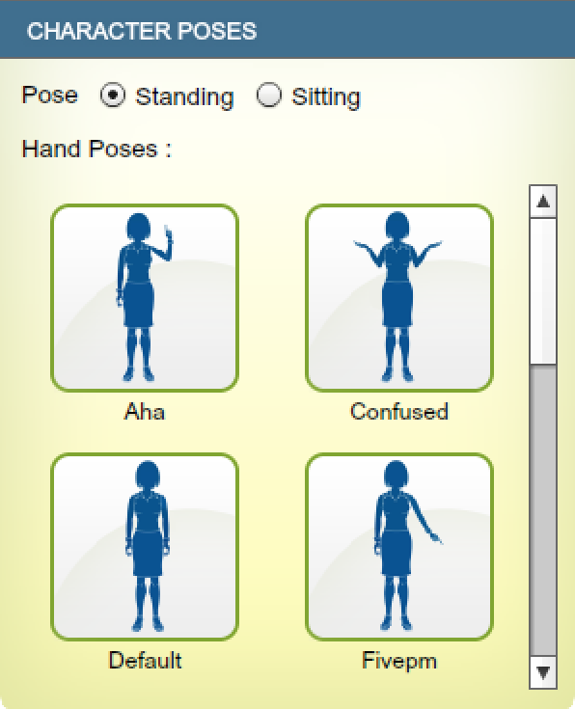

Expression
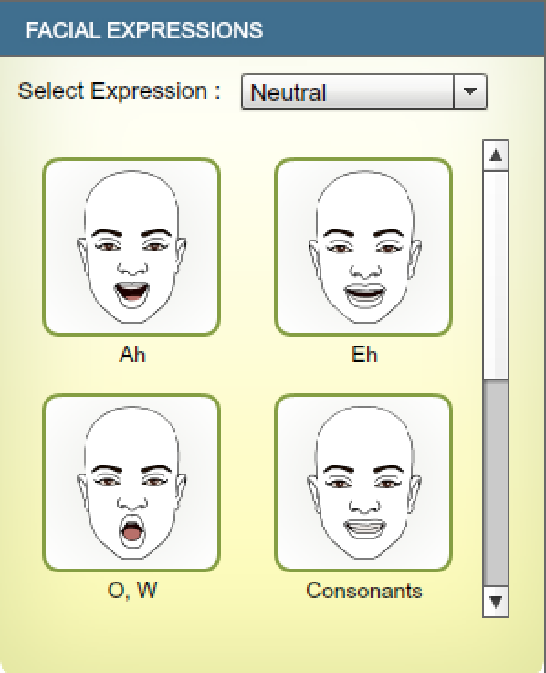

Attire
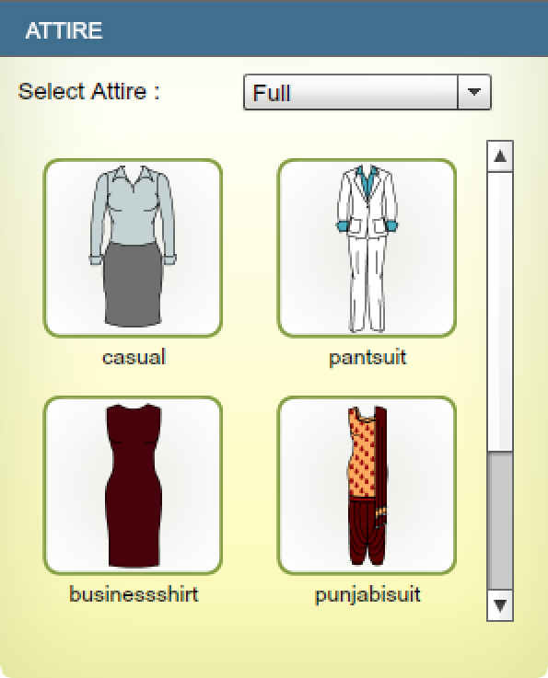

Library
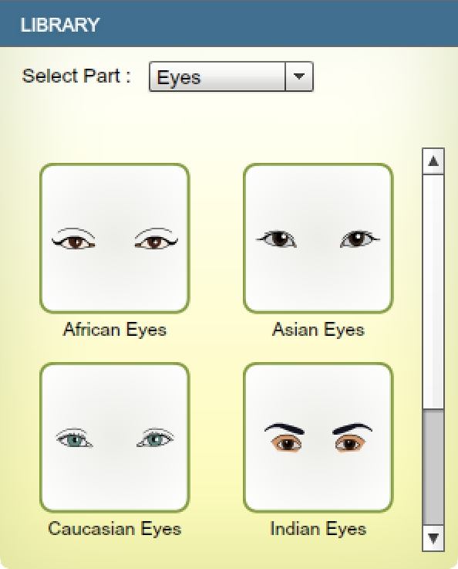

Transform sliders
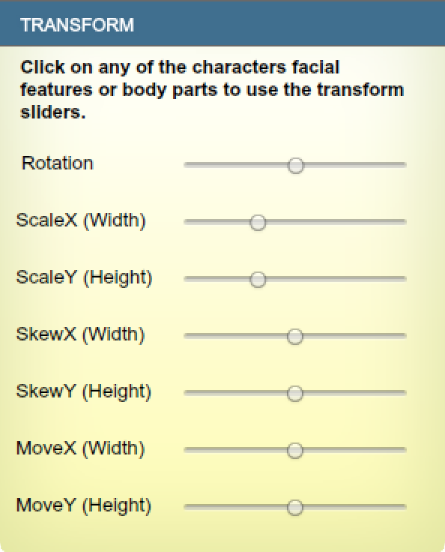

Mouse transformations
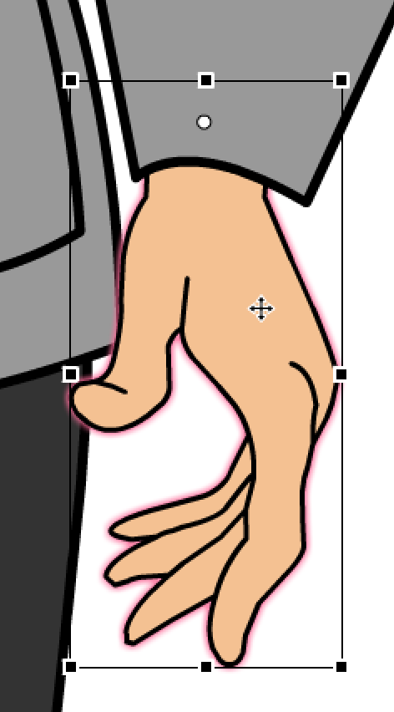

Paint
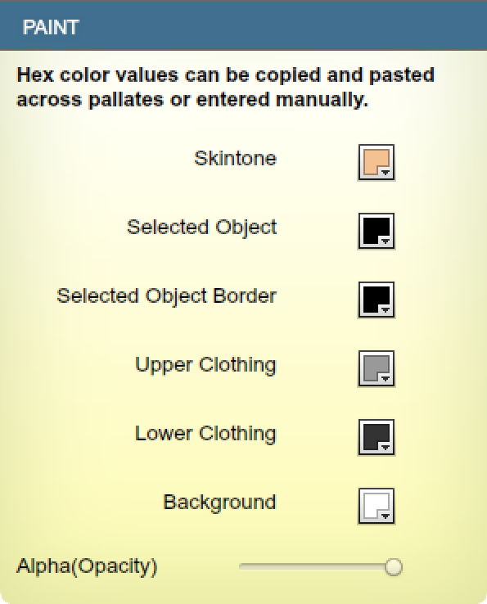

Random

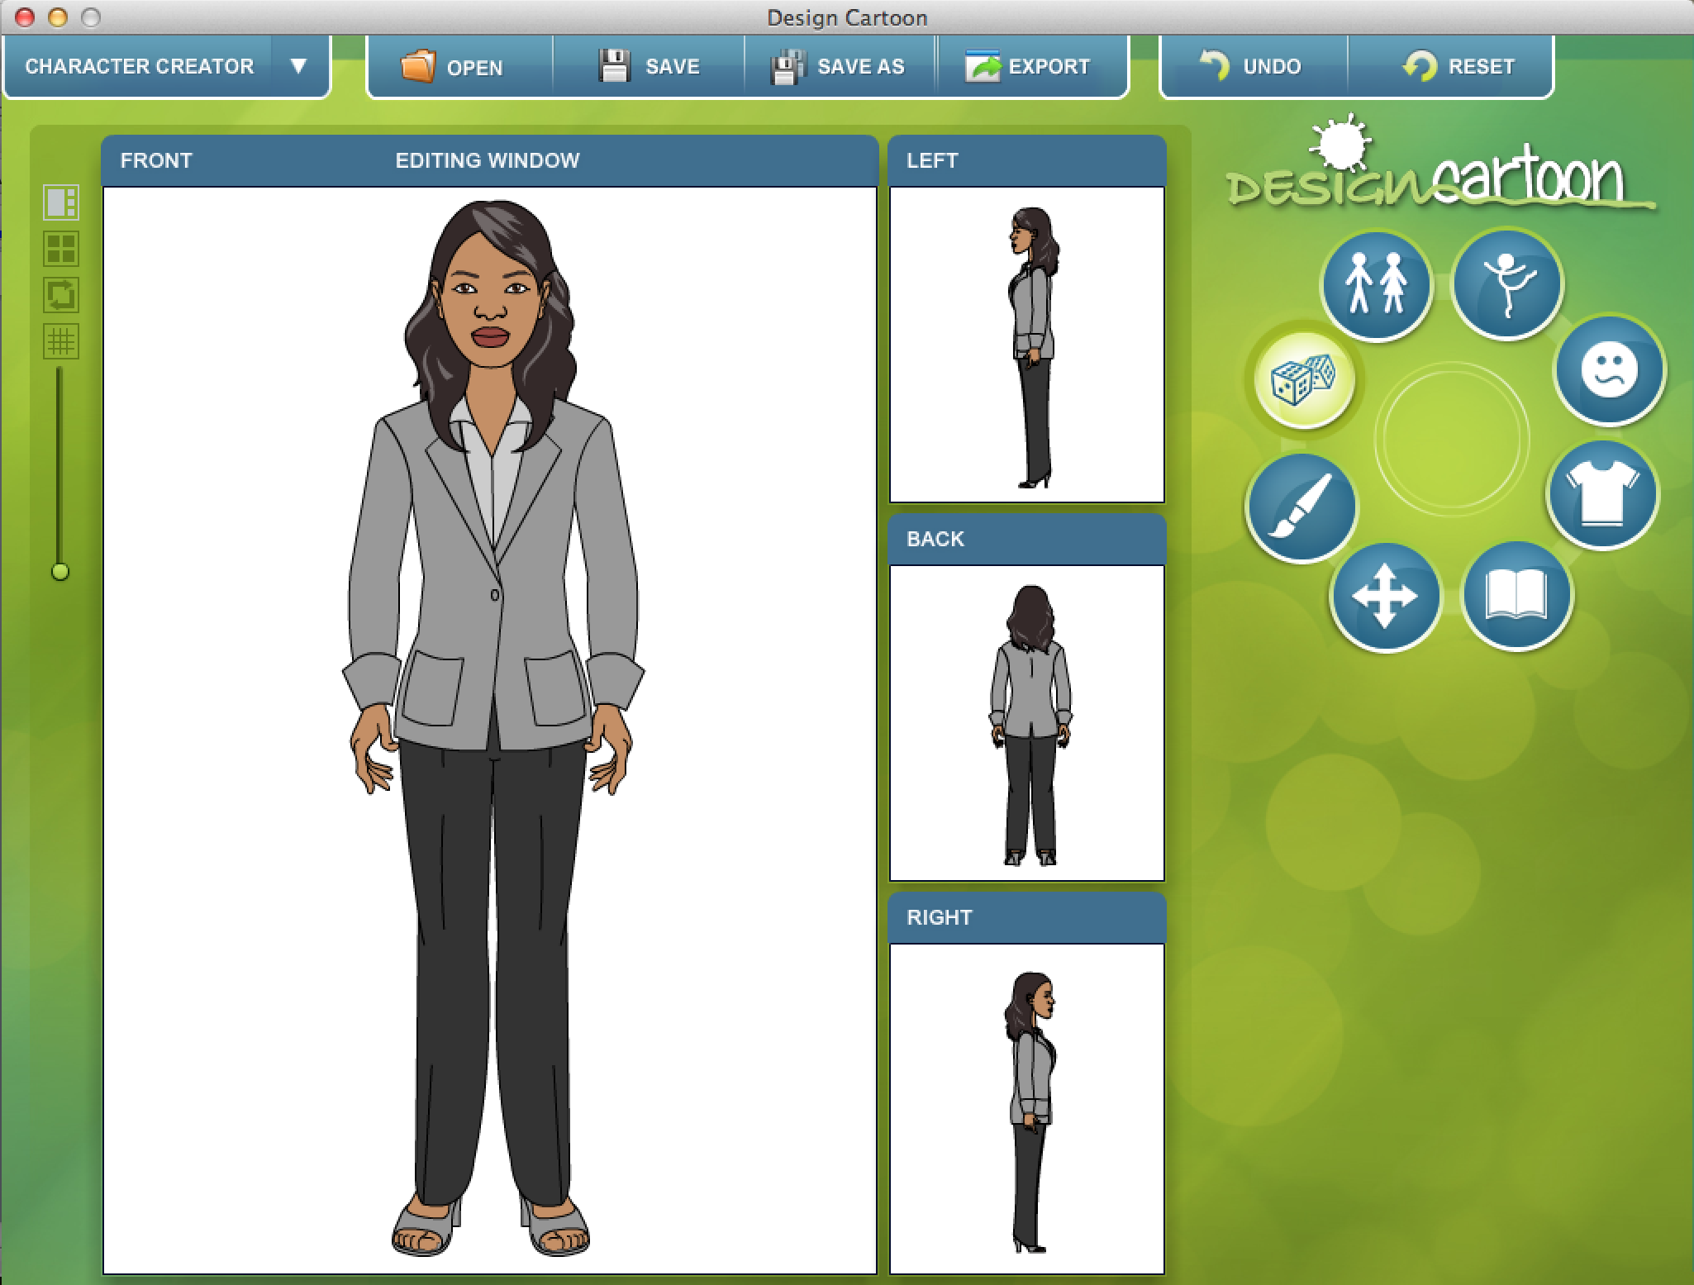

Chapter 3: Background Creator Basics

Once you start this application like the other two applications you have the option to open an existing project file or start with a new Background Selection.

Background Selection

There are two-dozen backgrounds to choose from. Most are staged with a particular interior room or exterior location that is corporate business focused. However you can start with the Blank or the Walls of a Room to design your own background. We also offer a telephone option to support any phone-based conversations. You can also import an image and push it to the back layer to be used as a background.

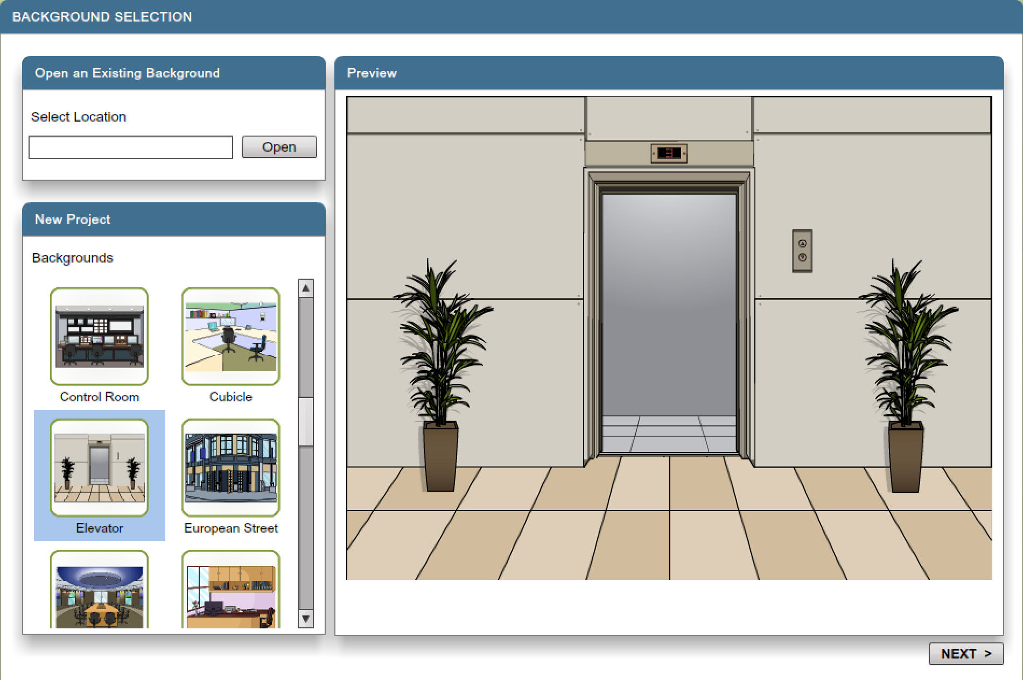

Editing Window (Normal)

You can add and subtract objects from the Library on the right as well as setting the object’s transparency (alpha).

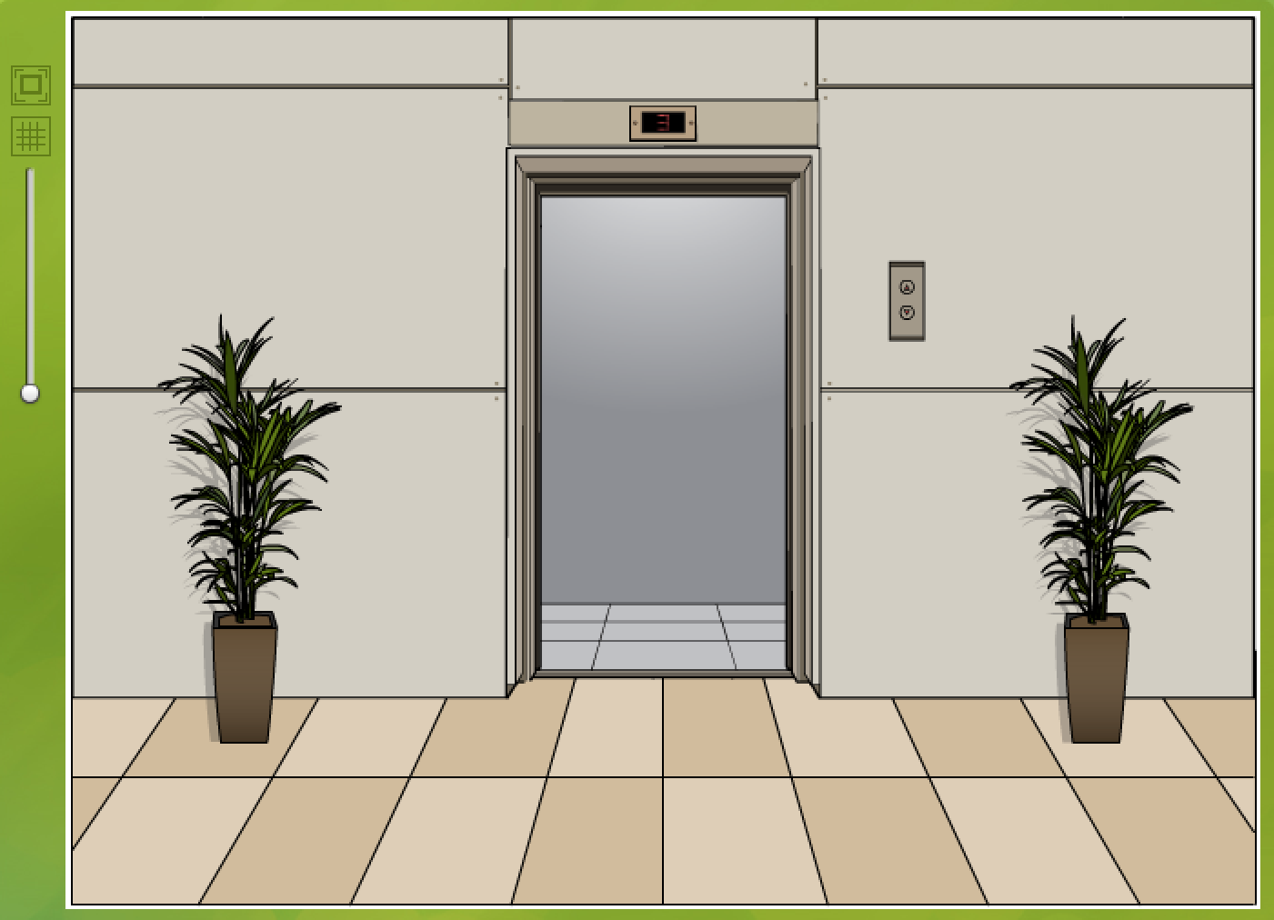

Editing Window (Full Screen)

Zoom
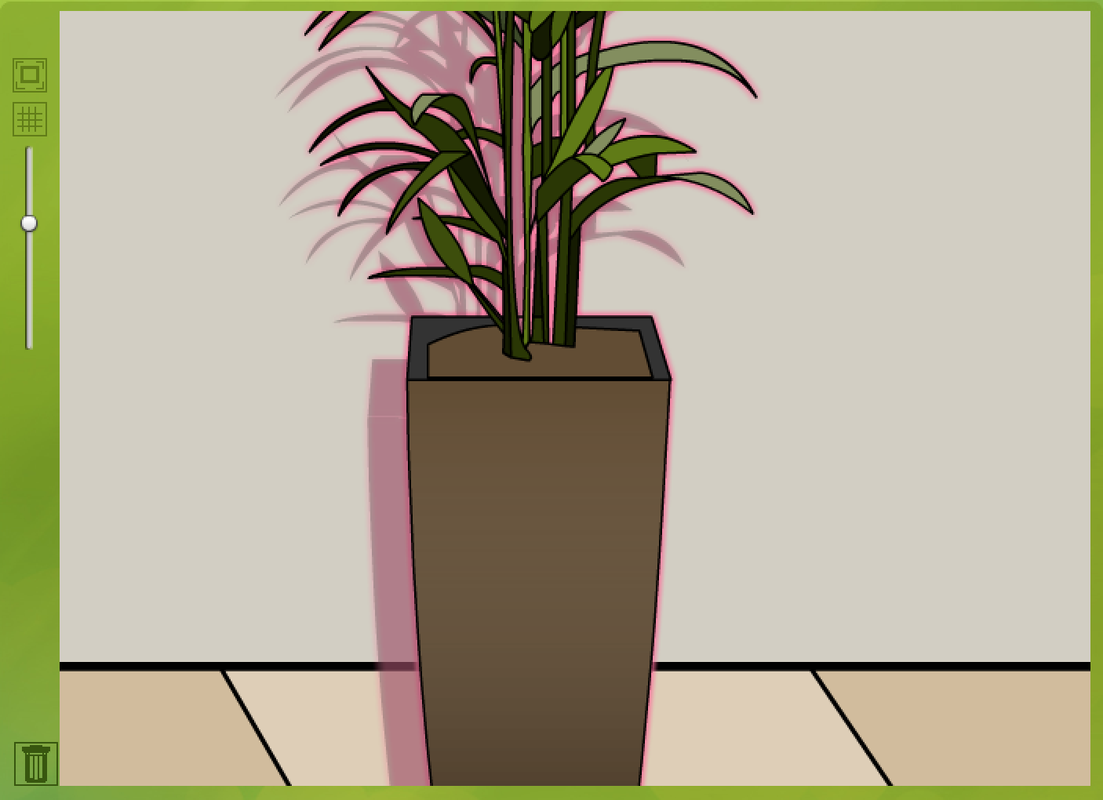

Grid

Circular Tools Panel

Background

Library

Layers

Characters

Transform

Paint

Import

Chapter 4: Storyboard Creator Basics

Layout Selection
Background Image
Library
Layers
Text
Transform
Paint
Import

Chapter 5: Character Creator Advanced

How-to modify characters to look younger or older
How-to modify facial expressions
How-to create monsters and aliens

Chapter 6: Background Creator Advanced

How-to create your own backgrounds
How to mirror and rotate images
Perspective (sizing characters and objectives)

Chapter 7: Storyboard Creator Advanced

How-to create a comic book

Chapter 8: Printing

PDF Export

JPEG/PNG Export

Chapter 9: Technical Support & Updates

FAQS
Blog
Email Support
Adobe AIR Updates
Product Updates
Uninstalling

Appendix A: End User License Agreement

Appendix B: Business Justification Matrix

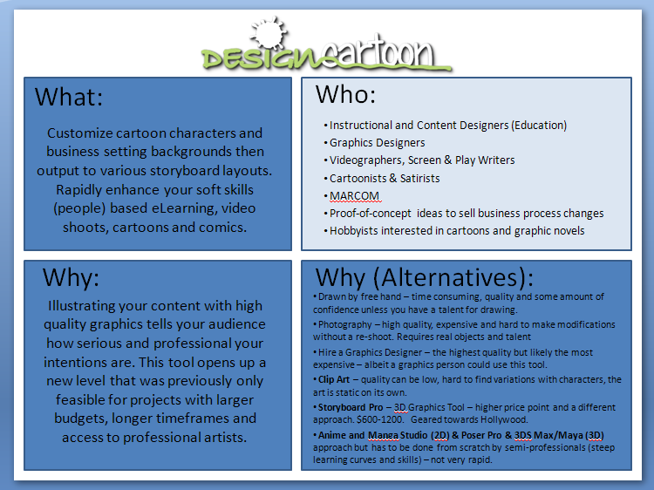

Appendix C: Features and Workflow Job Aid

